Computer Language Coding Concepts

Relations Between Objects in a Diagram
The concept of relations between objects is explained in the article Relations Between Objects. The current article only explains its expression in a diagram.

The main rule about relations to object is: for each reference to an object, the other object contains a reference back.

When you draw out the separate counterparts of a relation between two objects it looks like this:

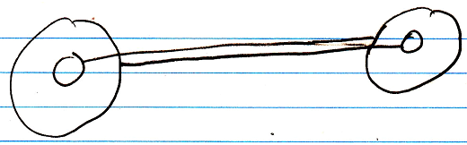

But to express the close relation between the two references, the two lines are merged, and disambiguated from normal object lines with a relation symbol:

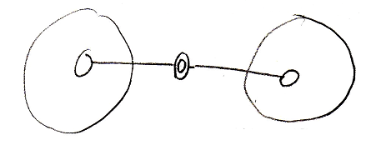

The relation symbol is a double circle. The reason behind this notation, was already explained in the article Relations in a Diagram. The notation is accomplished by first taking the original picture with one class refering to another and the other refering back to the first class:

Then, an imaginary reference to each class is added to the diagram

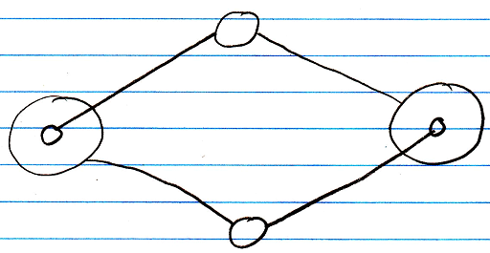

Next, the class lines are merged, but also the class symbols are merged:

The notation would still be ambiguous, if it weren’t for the double line of the merged object symbols. So a double circle symbolizes a relation between objects.

For relations between classes the relation symbol is a double dashed circle. For relations between objects, the relation symbol is a double circle drawn with solid lines.

In 1 → n and n → n relations the rule, that each reference contains one reference back, also applies:

1 → n:

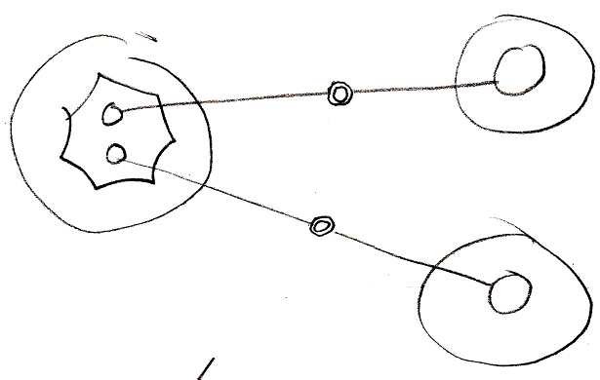

n → n:

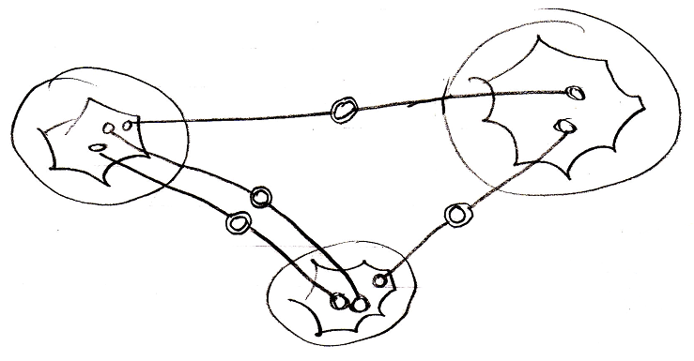

It doesn’t matter whether an object reference is part of a list or not: every time it is still two individual object references, that are tied together.

Object relating to itself
Sometimes an object relates to itself. In a diagram this looks as follows:

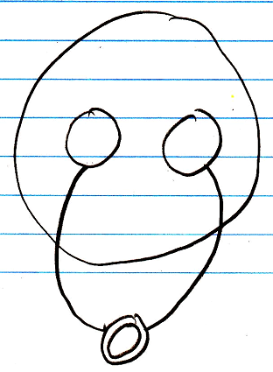

Counterpart out of sight
When the counterpart of the relation is out of sight, a line should point out of the diagram. A catch there is, that you can’t see if the relation counterpart is part of a multiplicity of n or not. Therefore, the multiplicity is expressed at the end of th line pointing out of the diagram as follows:

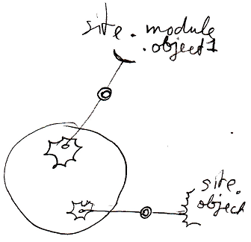

No reuse of merged imaginary references
If two imaginary references have merged, to become a relation symbol, then other references to the same objects won’t connect to an imaginary reference that has merged to become a relation symbol. Relations create their own imaginary references, that aren’t reused.

Here is a relation between two objects:

The two objects refer to eachother. This originally consisted of two distinct references:

Imaginary references were put on one level higher:

If other references to the same objects were also displayed in the diagram, then they would connect to the same imaginary references, put on a higher level:

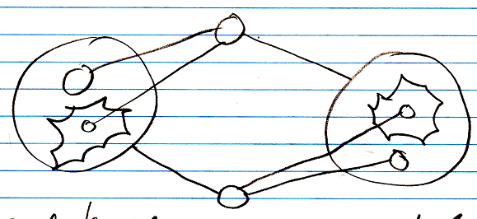

When you merge the imaginary references to display that two references are part of a single relation, you will not connect all
references to the merged imaginary reference:

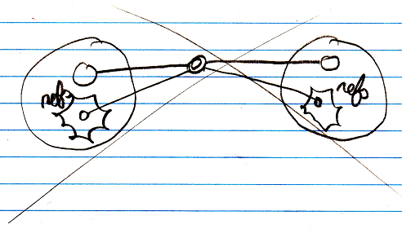

You will keep separate imaginary references for the other unary relations to the objects:

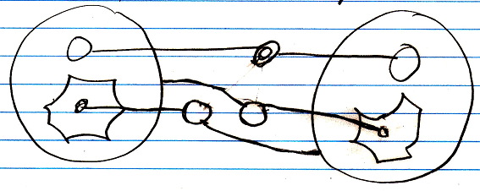

See also: Relations Between Objects, Relations in a Diagram

Author & Copyright: Jan-Joost van Zon Date: June 18, 2008 – June 18, 2008 Location: Oosterhout, The Netherlands Status: Finished

